**7Maths - Semaine 5**

**Problème de la semaine :**

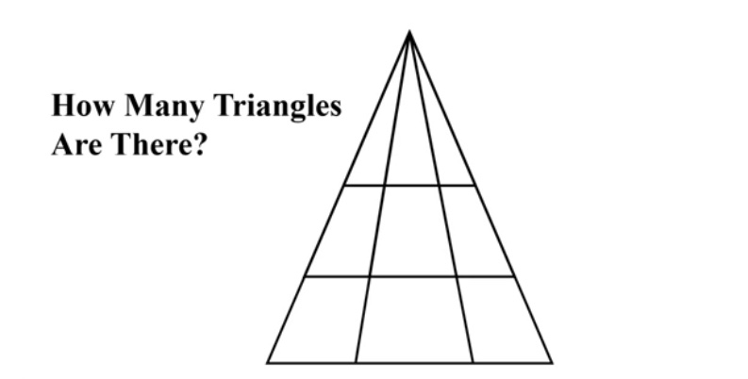

**Questions pratiques : L’aire des rectangles,parallélogrammes et triangles**

<https://courseware.cemc.uwaterloo.ca/27/95/assignments/855/0>

a) Click on the link above for lessons and practice questions on Area.

* The section “Area of a Rectangle” should be review from grade 6.
* The sections “Area of a Parallelogram” and “Area of a Triangle” might be new for some of you.

b) Complete those 3 sections which include explanations, diagrams and practice questions.

c) You can also check out the “Review” and “Practice” sections.

d) Once you have completed the lessons and practice, you should be ready to complete the following Worksheet.

**Exercises : L’aire**

Trouve l’aire des figures suivantes. Montre le travail.

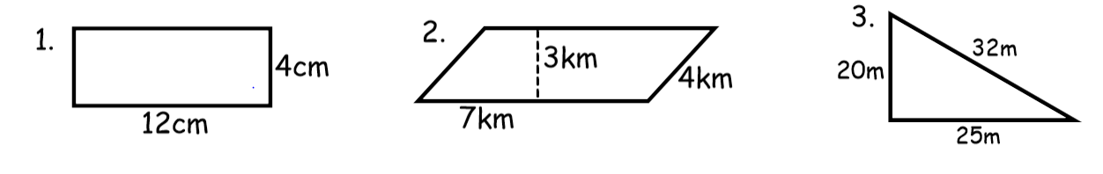

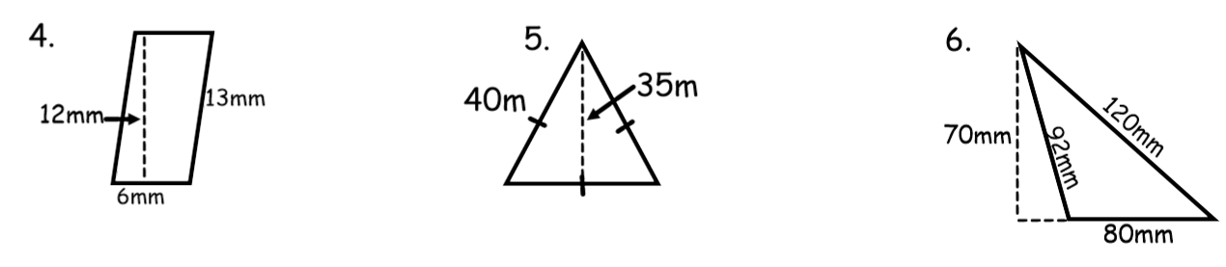

Trouve la valeur inconnue. Montre le travail.

